

.

BELLBIRD PUBLIC SCHOOL

*Inspirational ~ Nurturing ~ Unique*

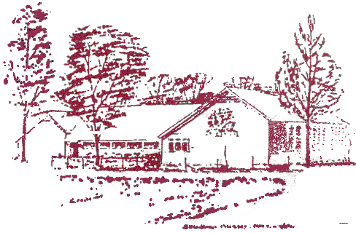

2010

Excursion Policy

***Principal ~ Bellbird Public School***

**Mr John Millburn**

*School Address****:*** Doyle Street*Phone****:*** 02 4990 2331

Bellbird 2325*Fax:* 02 4991 1973

*Postal Address****:*** P.O. Box 484,

Cessnock 2325

*Email:*[*bellbirdp.school@.edu.au*](mailto:bellbirdp.school@.edu.au)

*MCj01047340000[1]*

PURPOSE:

Educational excursions are undertaken to enrich student learning by providing opportunities for experiential learning in the wider community setting.

BROAD GUIDELINES:

* Excursions will take place at the discretion of teachers according to relevance to learning programs. Consequently, excursions may vary from year to year.
* As a general rule, teachers planning excursions will ensure that all students within the specific learning group involved will be given the opportunity to participate.

PLANS FOR IMPLEMENTATION:

3.1 Planning

* Relevance to learning programs is to be established along with effective pre and post excursion experiences. These are to be recorded in teaching/Learning Programs following approval.
* Proposed excursion discussed and approved by stage leaders, then Principal.
* A Risk Assessment plan will be completed for all excursions.

3.2 Responsibilities

* Excursion Organiser will take responsibility for: costing, bookings, arranging transport (safety a key issue), times/ dates, information and consent notes to parents (draft seen by Principal), excursion details to relevant participants.
* Money collections are to be made by class teachers of students involved, noted in money folder then sent to School Assistant.
* Teachers attending are to ensure that any in-school duties are covered whilst they’re on excursion.

3.3 Attendance

Students who wish to participate in excursions represent our school and therefore must take responsibility for:

* Following supervising teacher and adult instructions to ensure their own and others’ safety.
* Exemplary behaviour that enhances the good reputation of our school.

Any student who cannot take these responsibilities will not be allowed to attend the excursion. Parents will be informed to this effect prior to the excursion and an alternate program will be provided.

3.4 Walking Excursions

* These are undertaken around Bellbird, planned by teachers to provide learning experiences in the local community. A permission note is sent home at the beginning of each year to cover the whole year.

4. EVALUATION

* Evaluation will form a part of the teacher’s Program.
* An Excursion Checklist containing an evaluation of the excursion will be completed by the excursion organiser and kept in the excursion file for future reference.