

Bellbird Public School
Homework Policy


Appendix One

Grid Activities
~ Respectful, Safe Learners ~

Read a variety  of books | Be read to by another member of the family | Go shopping with  a family member
Spelling and  basic number  fact practice | Do some form  of housework | Physical activity /  Sport Training
Teach your parents something you were taught at school | Play a game with  an adult | Assignments  Projects  Research
Meditation  Spiritual  Relaxation | Use a computer  for work | Cultural /  Music Practice  Art

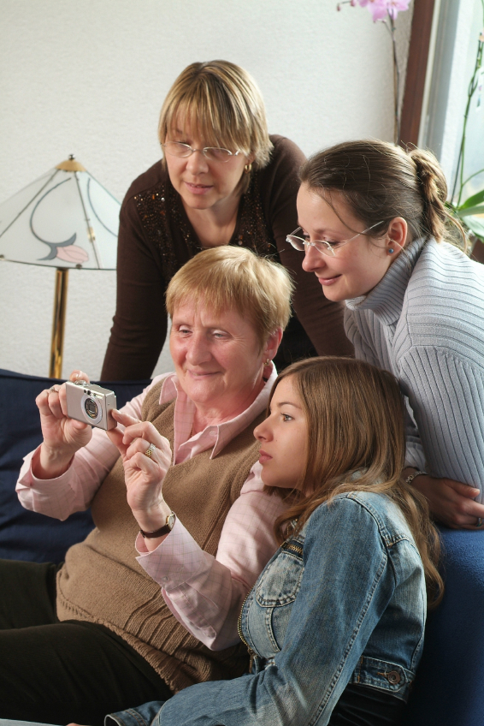



Bellbird Public School
Homework Policy


Appendix Two

Homework Grid Explanations

Read a variety of books | Students are to document the reading of a variety of books. These may include their home reader, library books, magazines, papers or online material.
Spelling and basic fact practice | This may be set on a regular basis by the class teacher.
Teach your parents something you were taught at school | Students will recall something they have learnt at school and tell, teach their parent or family member. It may be as simple as recalling a current affairs discussion or a maths, writing or science process.
Meditation Spiritual  Relaxation | Students are to document an example of relaxing or thinking quietly while attending church, scouts, sports training, a family trip etc.
Be read to by another member of the family | Students, even older students, love being read to. Try listening to and documenting some stories, poetry, sports stories, music lyrics, recipes, shopping lists.
Do some form of housework | Students are to document the completion of some form of housework. Even younger children can do a small job on a regular basis.
Play a game with an adult | Students are to document the playing of a game with an adult. It might be I Spy, cards, X box, cricket, soccer etc.
Use a computer for work | Students document when they used a computer for work/school. Examples might be research, writing spelling words, maths games, or writing a letter.
Go shopping with a family member | Students document a shopping trip with a family member. Students are to have an active role in the shopping trip
Physical activity /  Sport training | Students document their sporting activities for the week. Running, riding, backyard cricket and formal training all count.
Assignments  Projects / Research | Students complete simple to more complex projects based on class work
Cultural  Music practice | Students document any drawing, art, singing or music experience they engage in.


Bellbird Public School
Homework Policy

Appendix Three

Student Registration Sheet

Name____________________________________ Term _________________

Week | Home  Reading | Spelling Maths | Teach your parents | Meditation | Be Read to | House  work | Play a  Game | Use a  computer | Shopping | Sport | Projects | Music  Art
1
2
3
4
5
6
7
8
9
10

